Project | FusionDrive1MB | Confidentiality
Version | 0.1 | Page

BootROM Software Technology Solutions
---FusionDrive1MB

Document Change History
Release Version | Date | Change Description
0.1 | 2024/09/05 | Initial release

Document Change History 1
1. Introduction 3
1.1. System Overview 3

Introduction

System Overview

References

Terms and Abbreviations

Restrictive Constraints of Design
Class | Restrictive
CSE | shall complies with HIS-SHE specification 1.1

Software architecture

Architecture
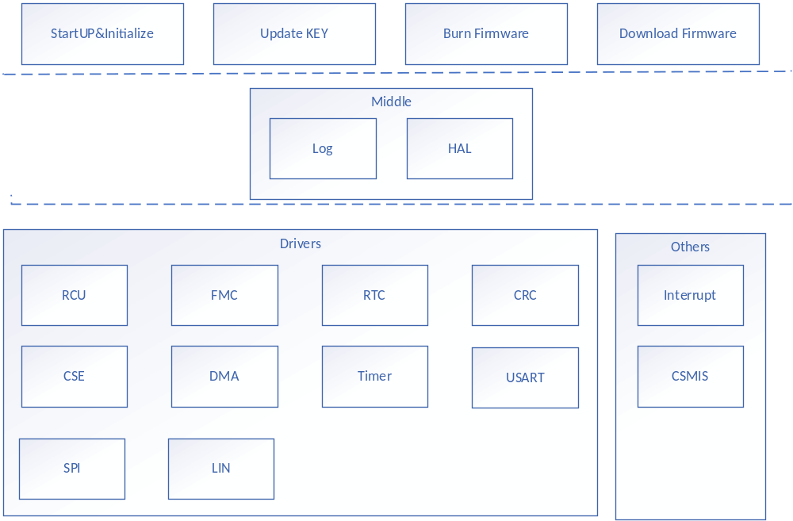

System Resource Design

CPU Resource

RAM & Flash Space
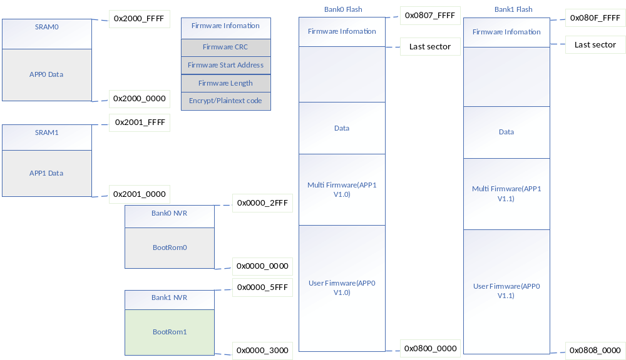

Index | Fusion-Drive-1M | Fusion-Drive-256K
1 | Program-0 : 512KB  Program-1 : 512KB  Data flash: 64KB | Program-0 : 256KB  Program-1 : N/A  Data flash: 64KB
2 | Co-work with CSE module | No CSE module
3 | Sector size:  Program flash: 1KB  Data flash: 512Bytes | Sector size:  Program flash: 512Bytes  Data flash: 512Bytes
4 | Boot-rom size: 24KB | 6KB
5 | Support RWW OTA | Not support RWW OTA

Interrupt
Device | Interrupt Number | Description
USART/LIN |  | Use to Burn /Download Firmware、Update KEY
Timer
SPI |  | Use to Burn /Download Firmware、Update KEY

Software Design

Function

Command

Firmware Info
Field Name | Range | Length(Byte)
Burn Addr | Bank0/Bank1 Flash Address | 4
Total Length | 0x1~(0x100000 – 0x200) | 4
version | User define | 4
is encrypt | 0:no need encrypt  1:need encrypt | 1
decrypted_address | RAM Space Address | 4
CMAC Value | CMAC Value for Firmware protected Area | 16
KEY ID used for encrypt | KEY1~KEY20  MASTER_ECU_KEY | 1

Command List
Command | Code | Description
Get Support Command[SEC] | 0x0 | Get the version of the bootloader and the  commands supported
Get Version(LIN Only?) [SEC] | 0x1 | Get the version of the bootloader
Get Group(LIN Only?) [SEC] | 0x2 | Get the group which the chip belongs to
Speed Change(LIN Only?) [SEC] | 0x3 | The speed command allows the baud rate for  CAN run-time to be changed.
Program Data(LIN Only?) | 0x4 | Data content with checksum
PRODUCT ID(CAN Only?) | 0x6 | Get product id
Read | 0x11 | Read no more than 256 bytes data from  specified address
Jump | 0x21 | Jump to an address to execute the codes there
Program Prepare | 0x30 | Prepare to program, send some firmware overview
Program | 0x31 | Program no more than 256 bytes data from a specified address
Erase(UART Only?) | 0x43 | Erase one or more pages of the main flash
Extend Erase | UART:0x44  LIN:0x14 | Erase one or more pages of the main flash using 2 bytes addressing information
Enable Erase/Program Protection | UART:0x63  LIN:0x0B | Enable some pages under the protection from erasing or programming
Disable Erase/Program Protection | UART:0x73  LIN:0x1B | Disable the protection from erasing or programming on the whole main flash
Enable Security Protection | UART:0x82  LIN:0x0D | Enable the security protection
Disable Security Protection[SEC] | UART:0x92  LIN:0x1D | Disable the security protection
Update KEY | 0xA1 | Update CSE Key
Delete All Key | 0xA2 | Delete All Key
Get Firmware Info | 0xA3 | Get Firmware info

Firmware Return Info
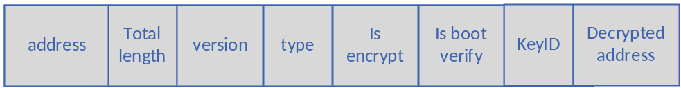

Burn Firmware
The firmware flashing function can be used to flash the firmware through BootROM. Users can either flash a firmware program or a multi-segment firmware program, and the user is responsible for the management of the relationship between the multi-segment firmware programs.
BootROM is only responsible for the management of the main entrance firmware program (verification, decryption, execution, etc.)

Download Firmware
The firmware download function can be used for users to download programs to memory via BootROM, which can be used for temporary debugging needs.

Update KEY
The key update feature can be used to update the user key, MASTER_ECU_KEY, BOOT_MAC_KEY via BooROM.

Burn Data
The flashing function can be used to burn the data required by the firmware to Flash.

Data Structure

firmware_info_t
typedef struct firmware_info {
uint32_t address; /* firmware start address */
uint32_t length; /* firmware length */
uint32_t version; /* firmware version */
uint8_t type; /* firmware type */
uint8_t is_encrypted; /* is need to encrypt? */
uint8_t encrypt_key_id; /* must be update key before burn */
uint32_t decrypted_address; /* decrypted memory address */
uint8_t cmac[16]; /* cmac value use BOOT_CMAC_KEY */
} firmware_info_t

Update_key_info_t
typedef struct {
uint8_t auth_keyid;
uint8_t auth_key[KEY_LENGTH];
uint8_t new_keyid;
uint8_t new_key[KEY_LENGTH];
} update_key_info_t;

Software Flow

Initialize & Startup
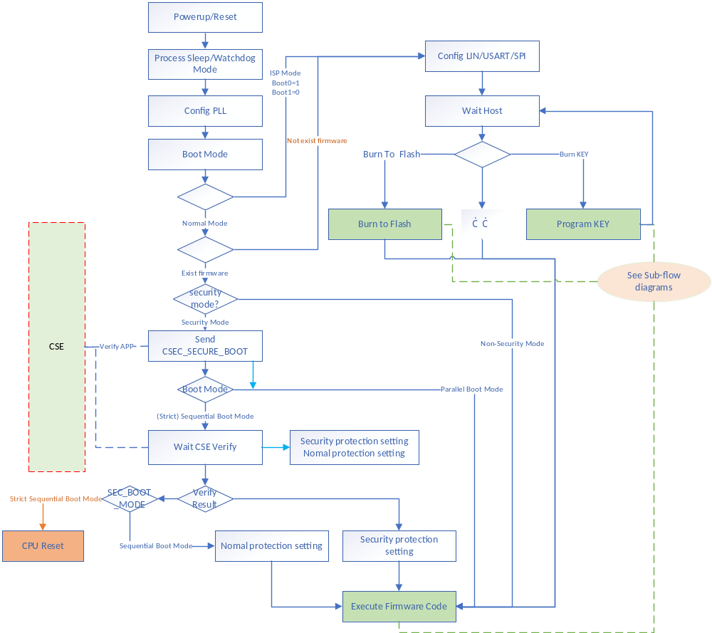

OTA & ISP Update

ISP Common Flow Chart

USART
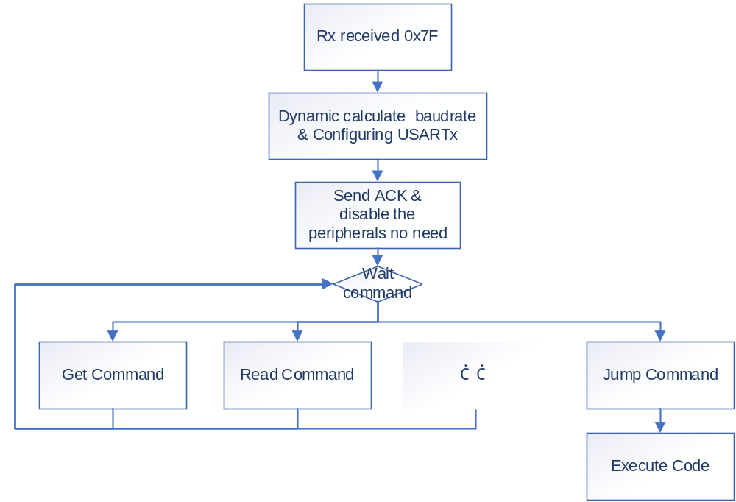

LIN
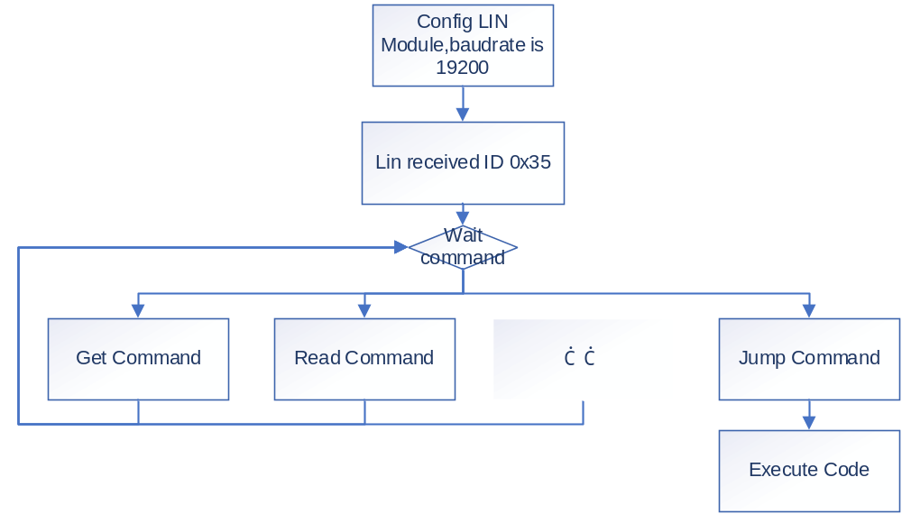

SPI

Get Command

UART

PC Flow
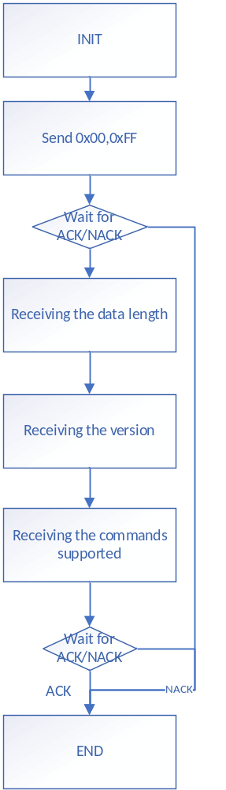

Boot Flow
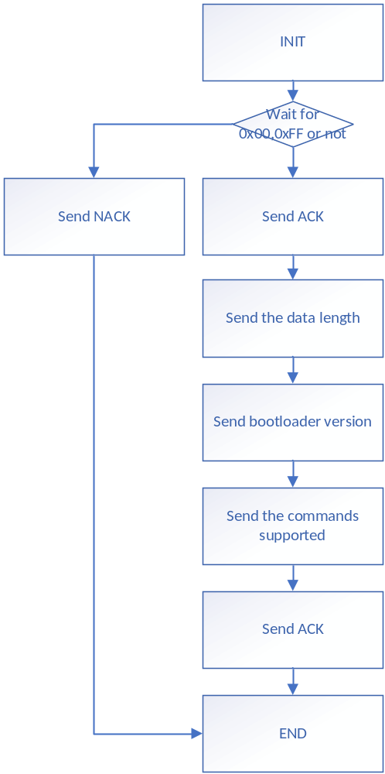

LIN

PC Flow
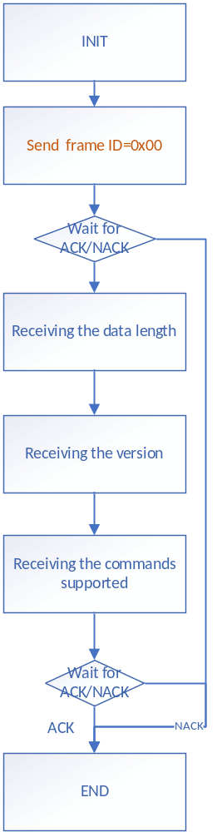

Boot Flow
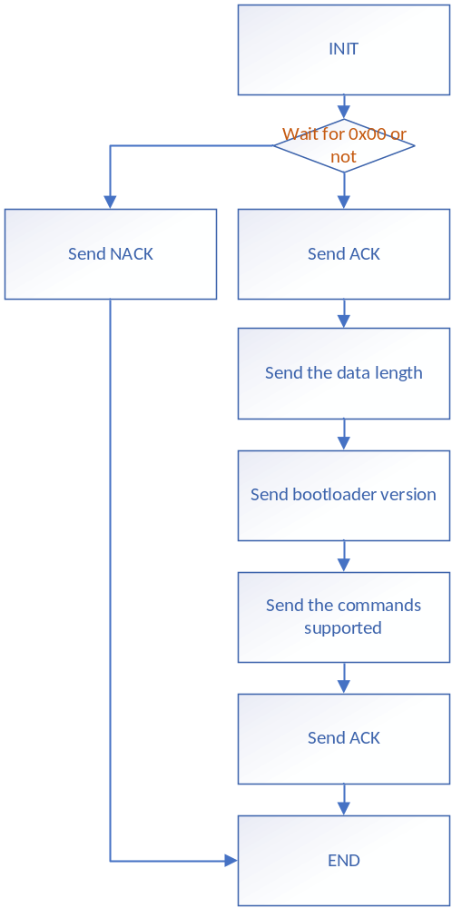

Get BootROM Version Command[LIN Only]

LIN

PC Flow
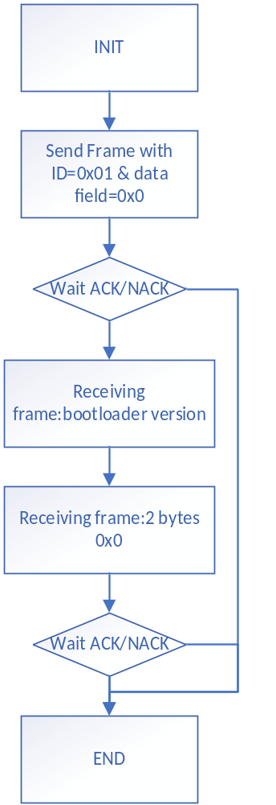

Boot Flow
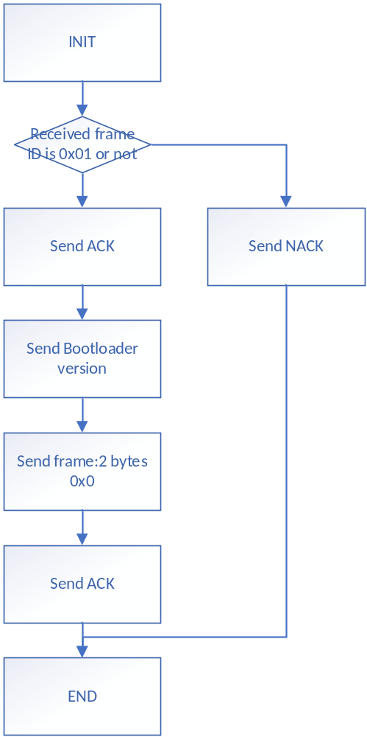

Get Group Command[LIN Only]

LIN

PC Flow
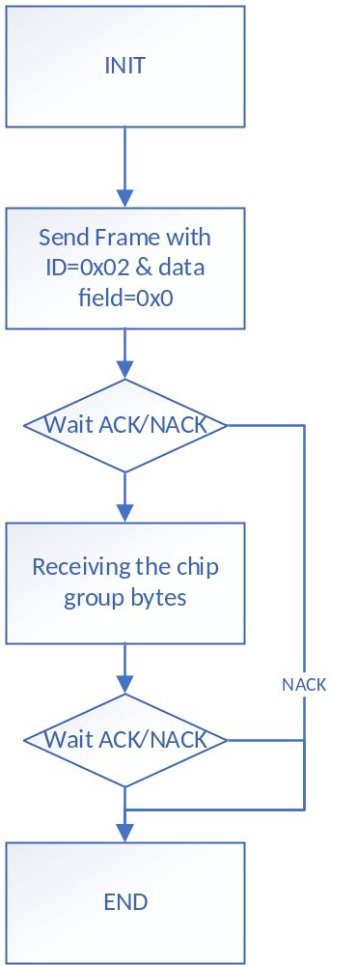

Boot Flow
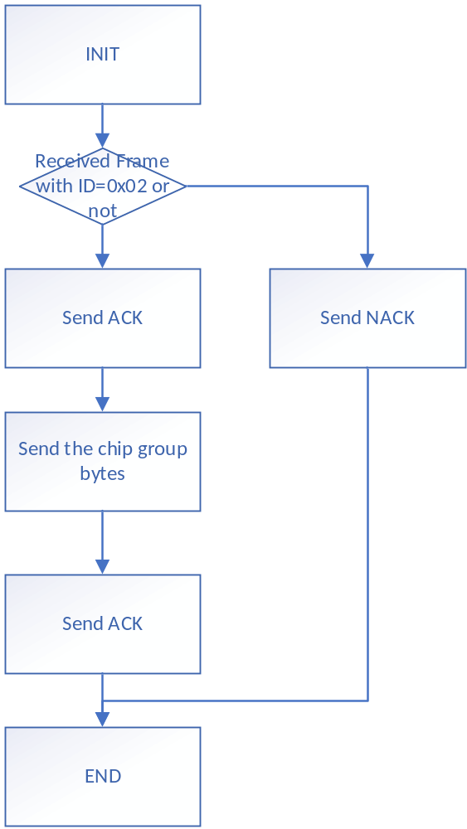

Speed Command[LIN Only]

LIN

PC Flow
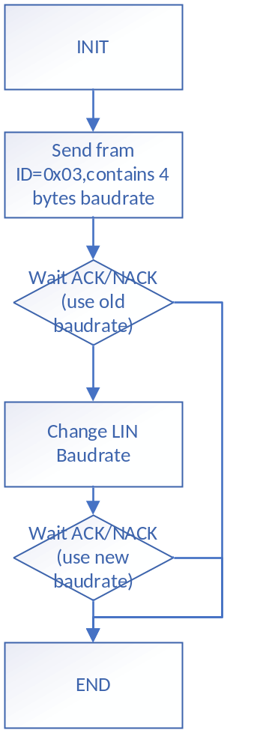

Boot Flow
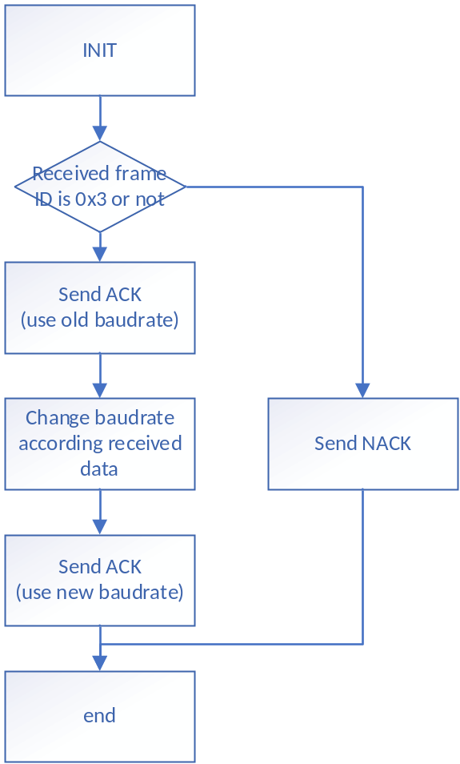

Read Command

UART

PC Flow
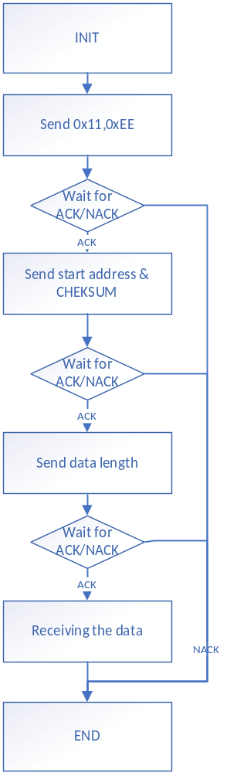

Boot Flow
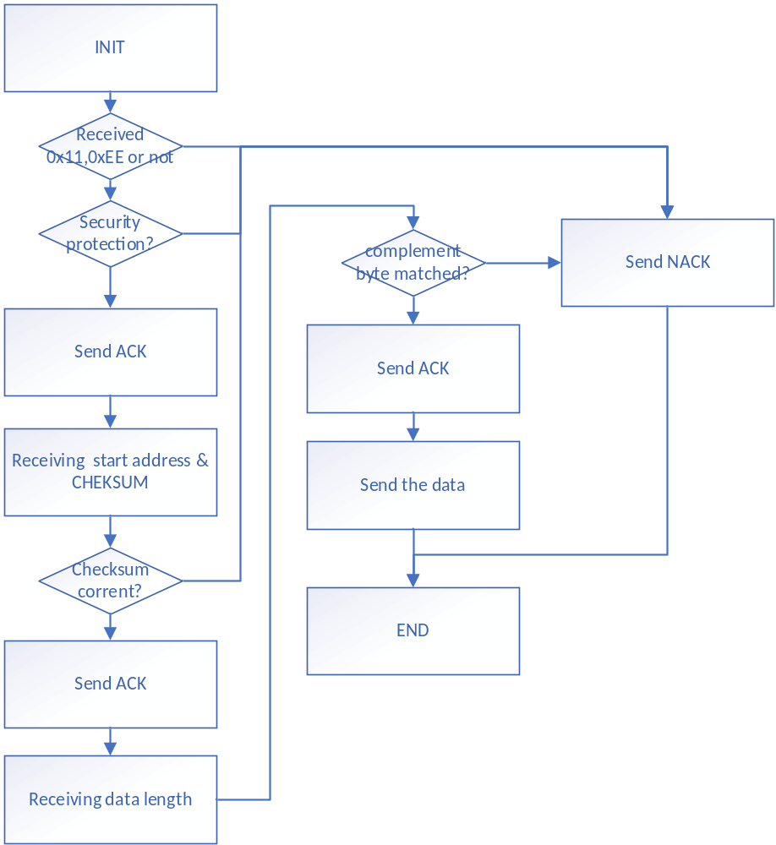

LIN

PC Flow
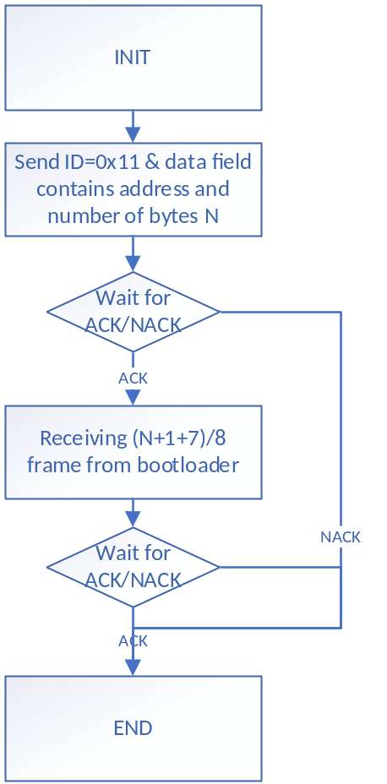

Boot Flow
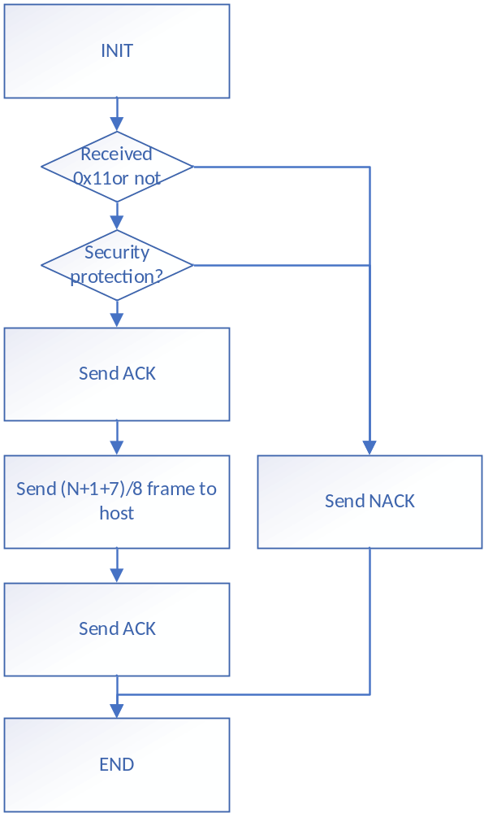

Jump Command

UART

PC Flow
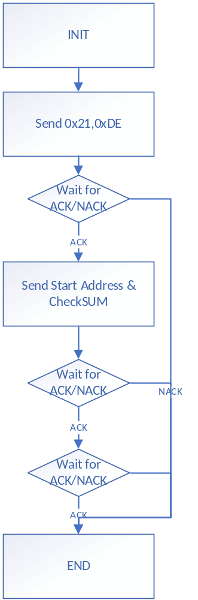

Boot Flow
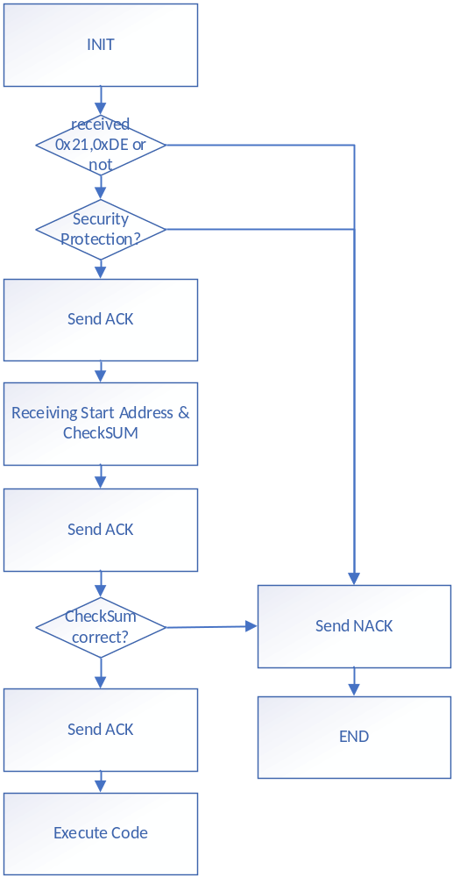

LIN

PC Flow
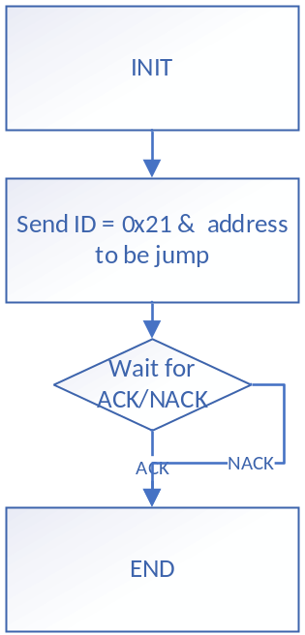

Boot Flow
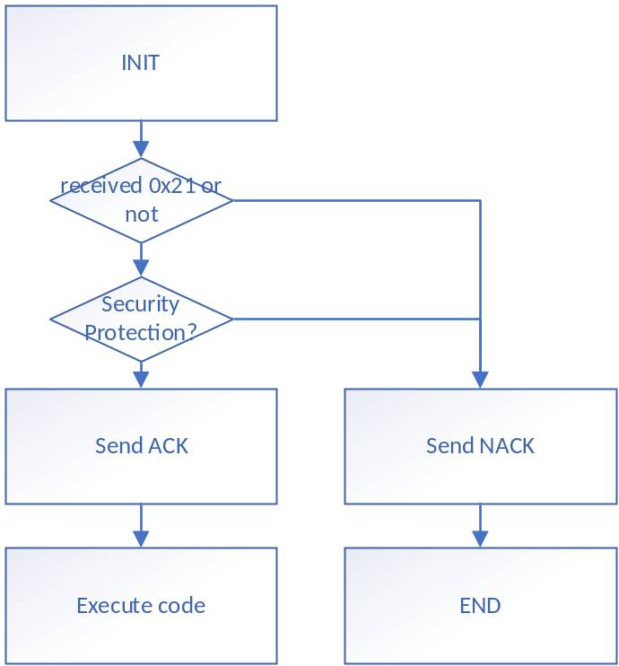

Prepare Program Command[New]

UART

PC Flow
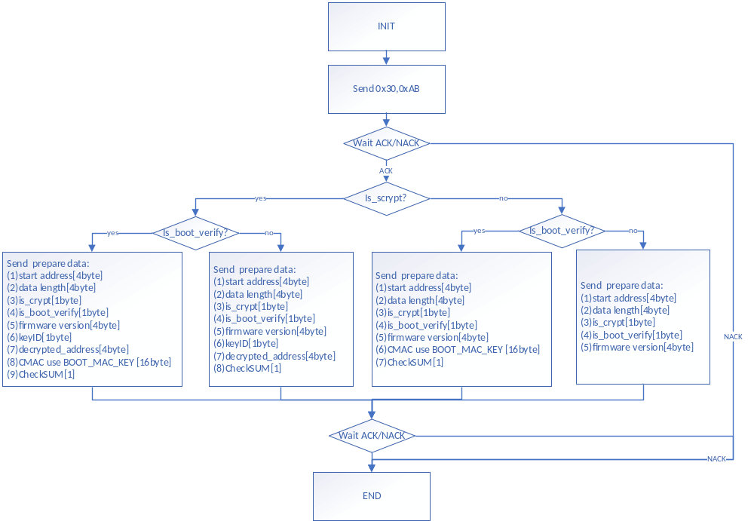

Boot Flow
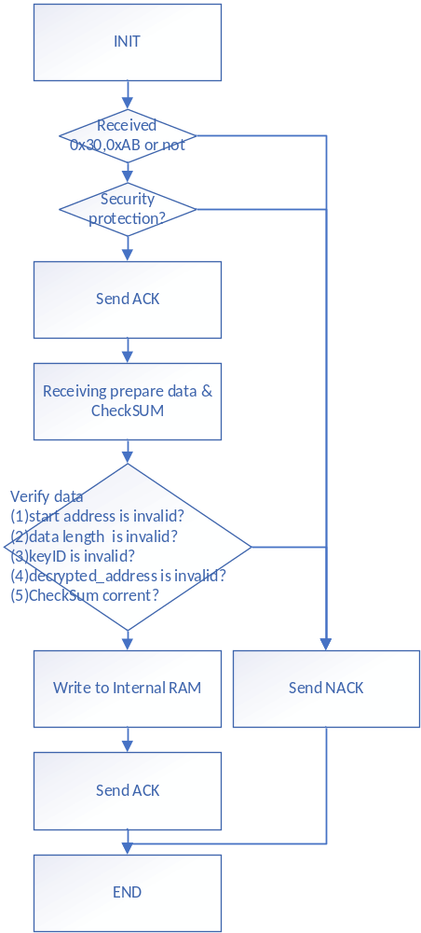

LIN
Same as UART

Program /Program Data Command[Modify]

UART

PC Flow
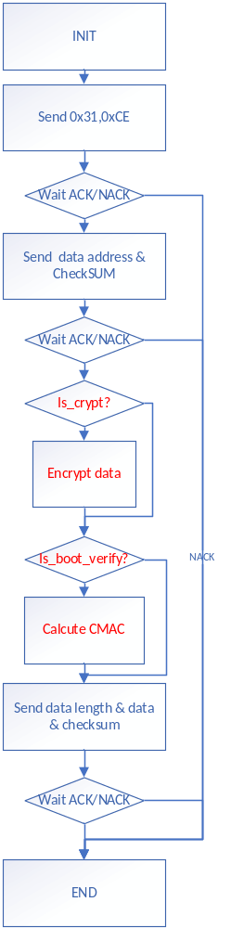

Boot Flow
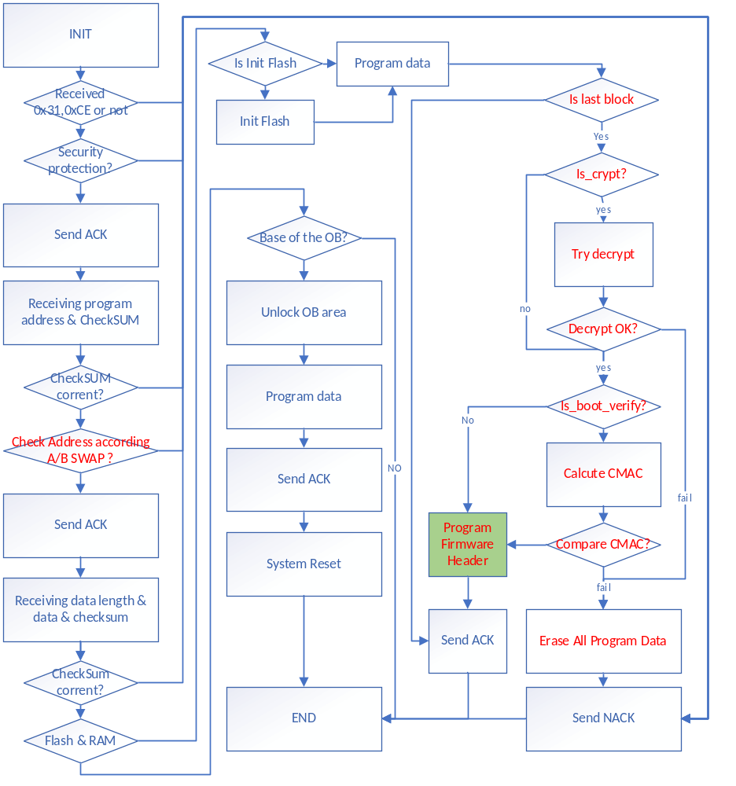

LIN

PC Flow
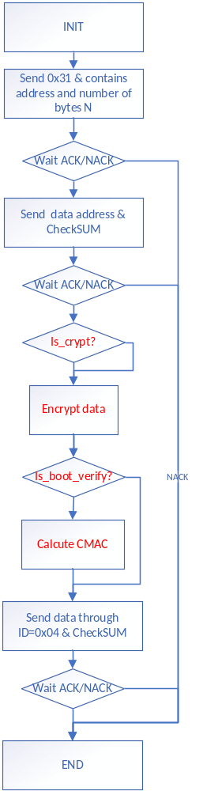

Boot Flow
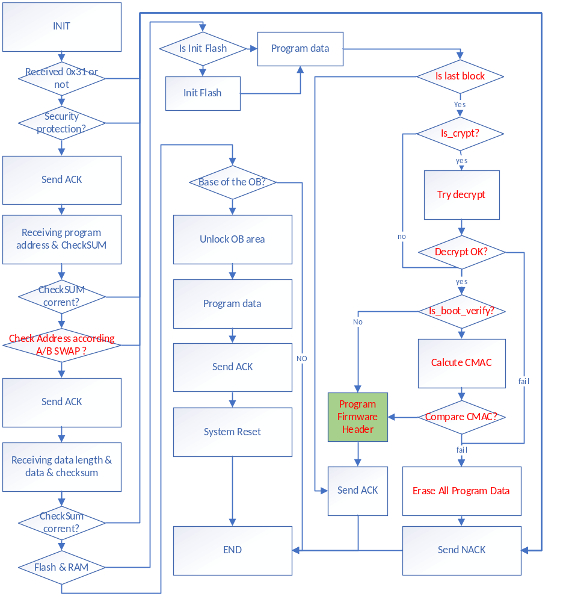

Program Firmware Info
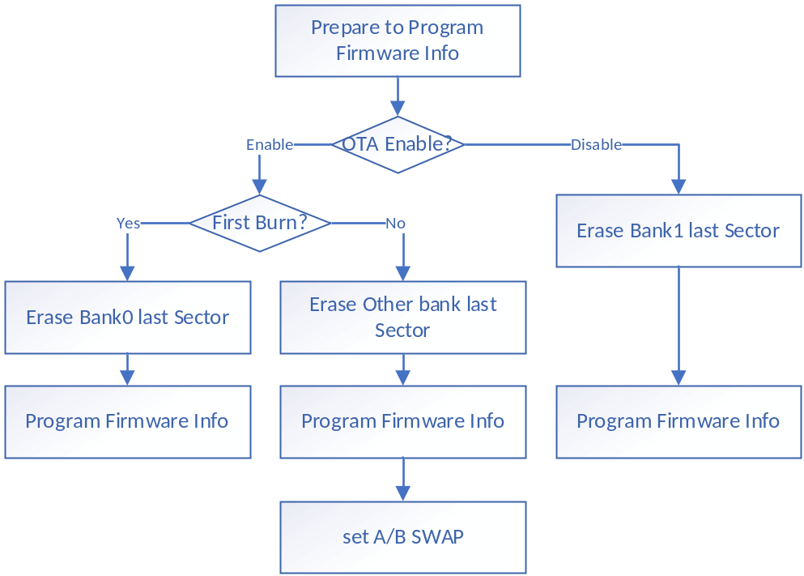

Erase Command[Modify]

UART

PC Flow
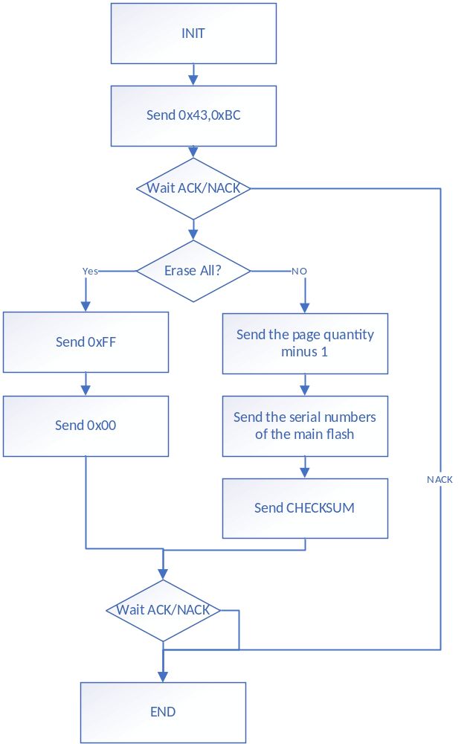

Boot Flow
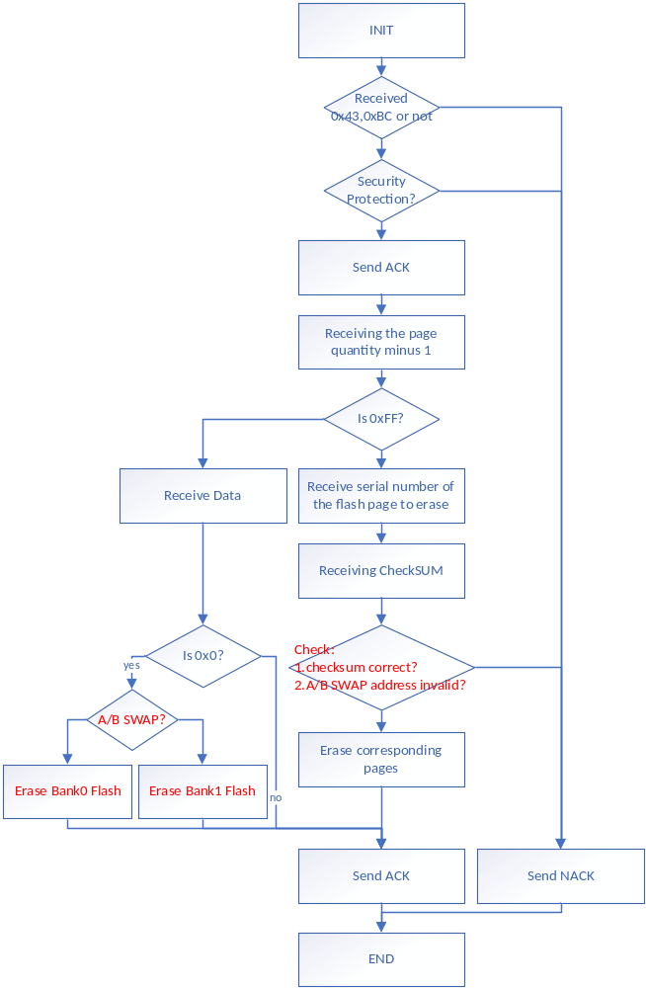

Extend Erase Command

UART

PC Flow
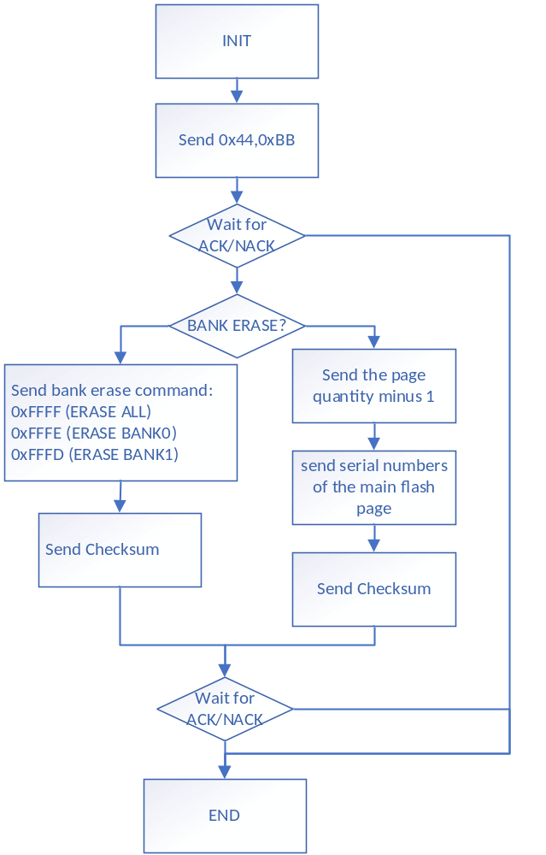

Boot Flow
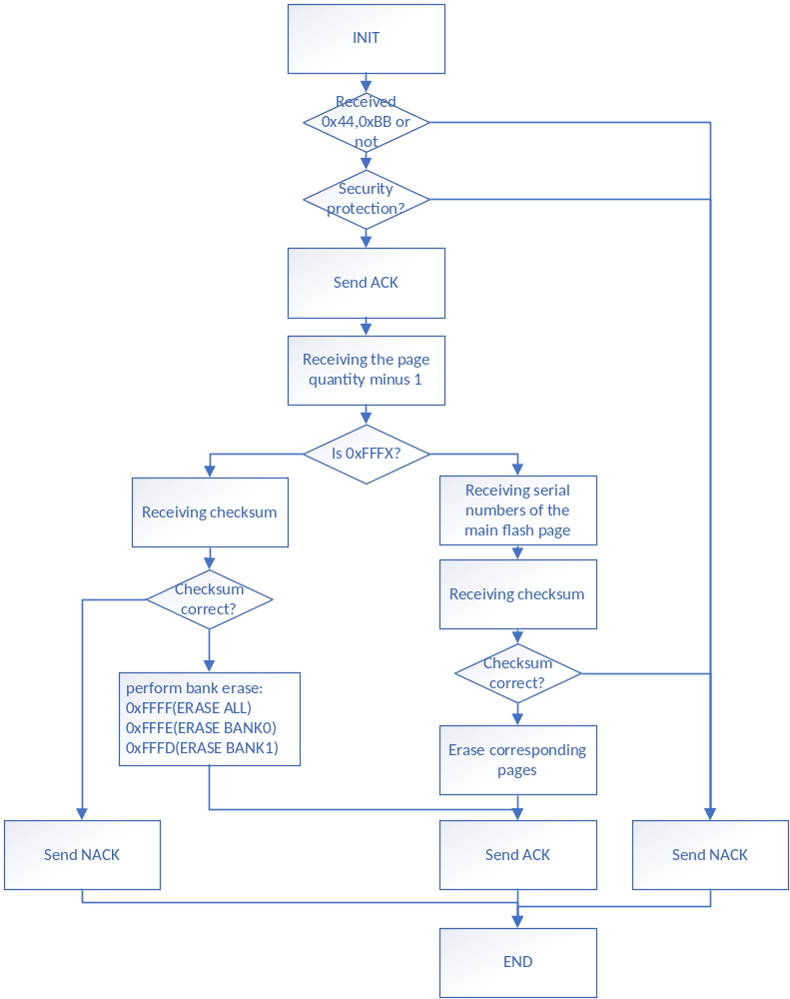

LIN

PC Flow
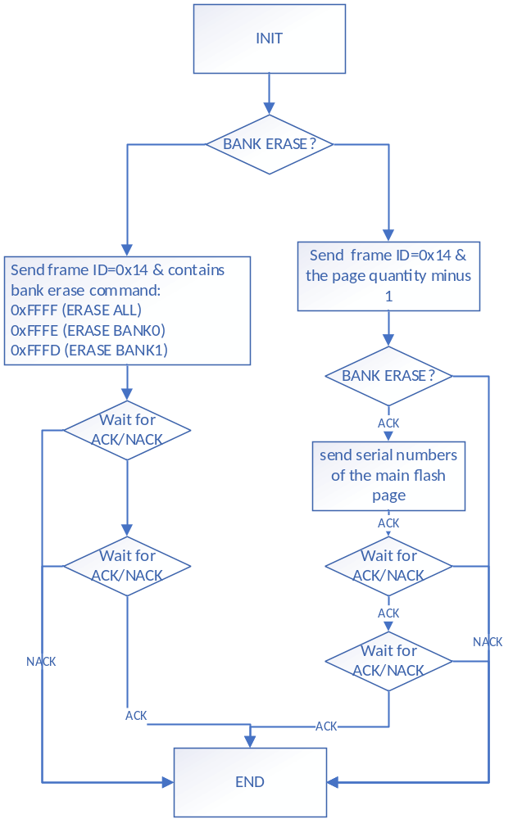

Boot Flow
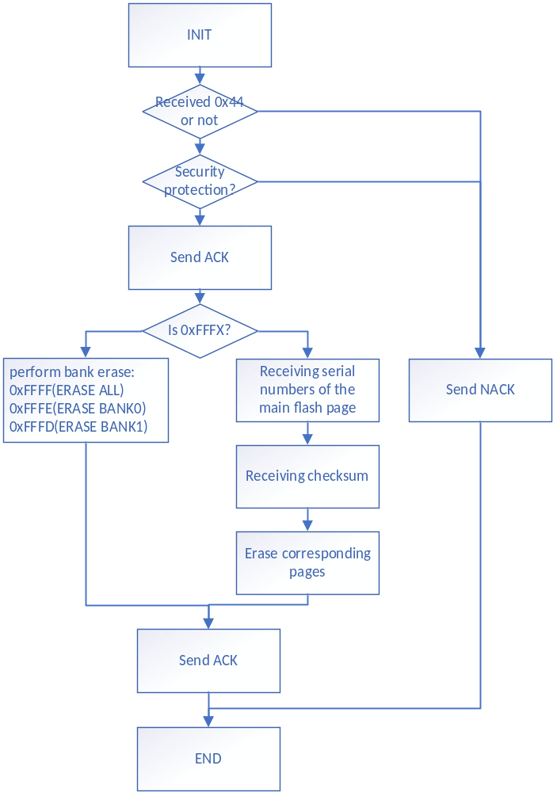

Enable Erase/Program Protection Command

UART

PC Flow
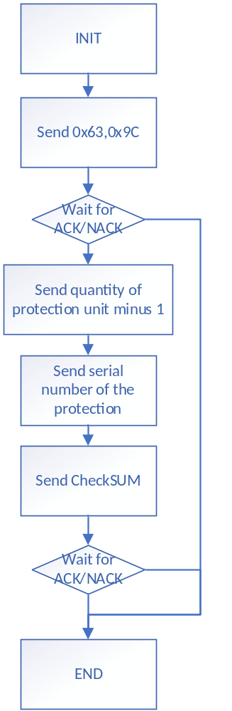

Boot Flow
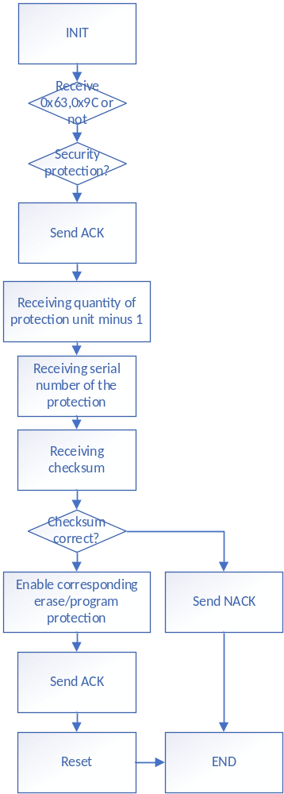

LIN

PC Flow
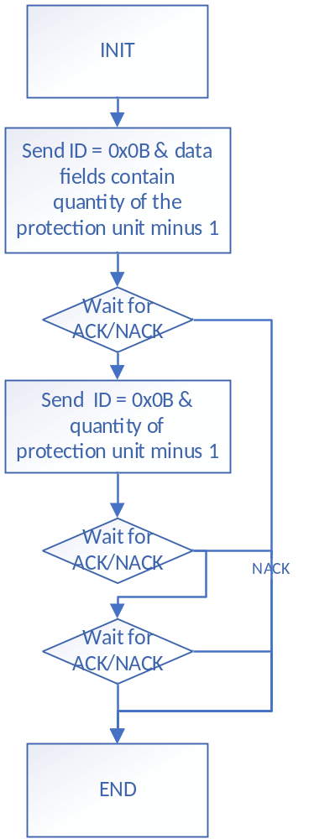

Boot Flow
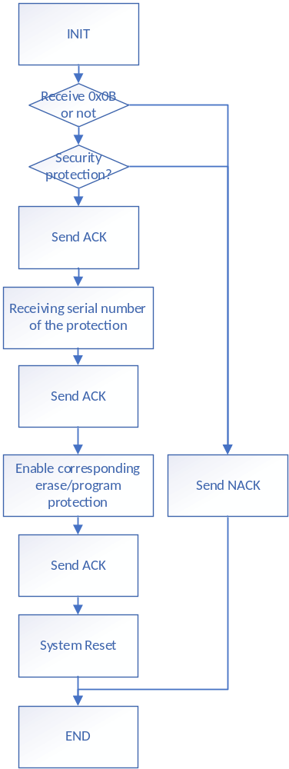

Disable Erase/Program Protection Command

UART

PC Flow
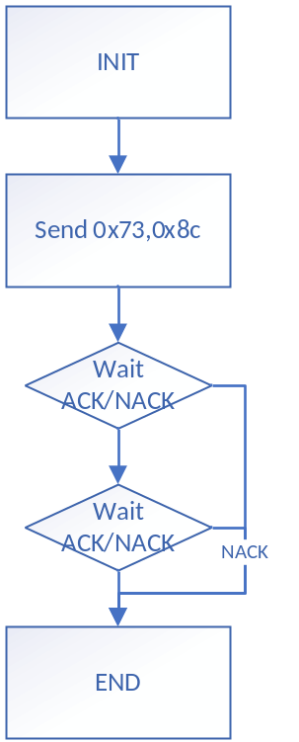

Boot Flow
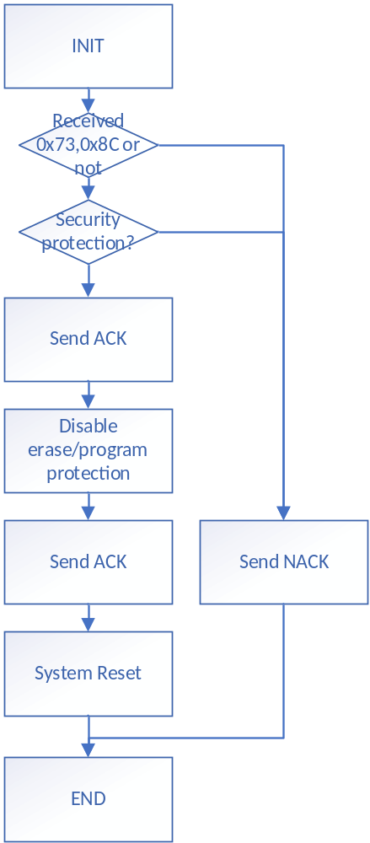

LIN

PC Flow
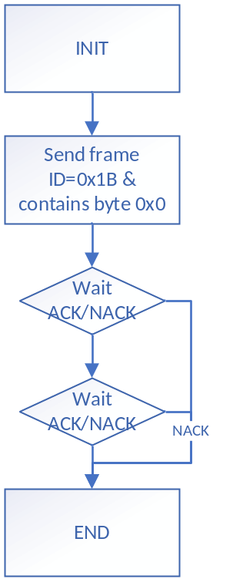

Boot Flow
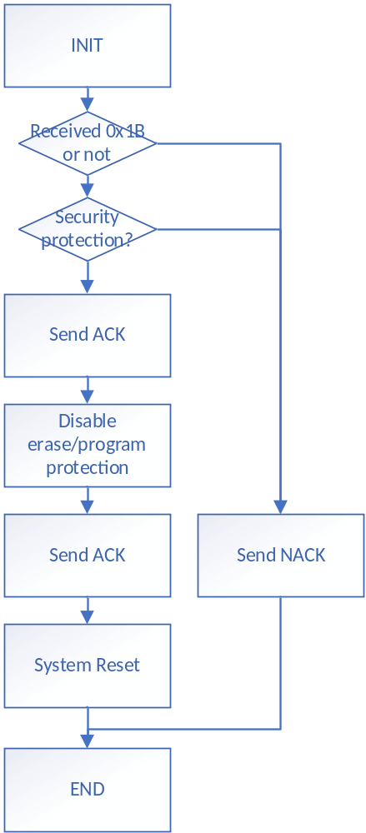

Enable Security Protection Command

UART

PC Flow
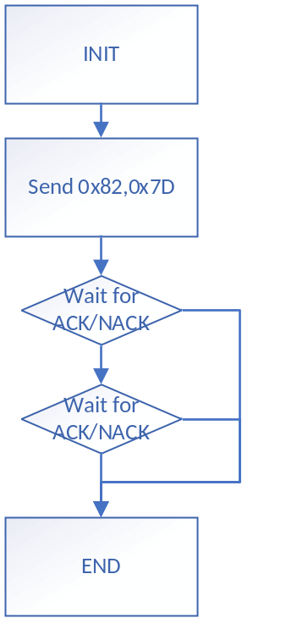

Boot Flow
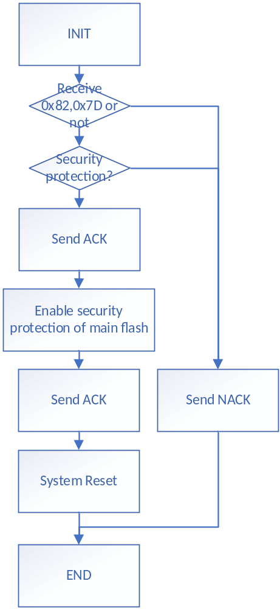

LIN

PC Flow
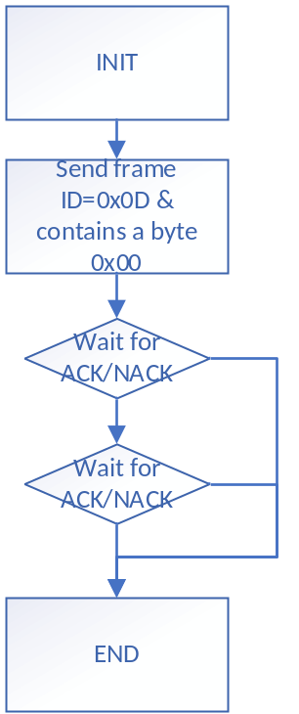

Boot Flow
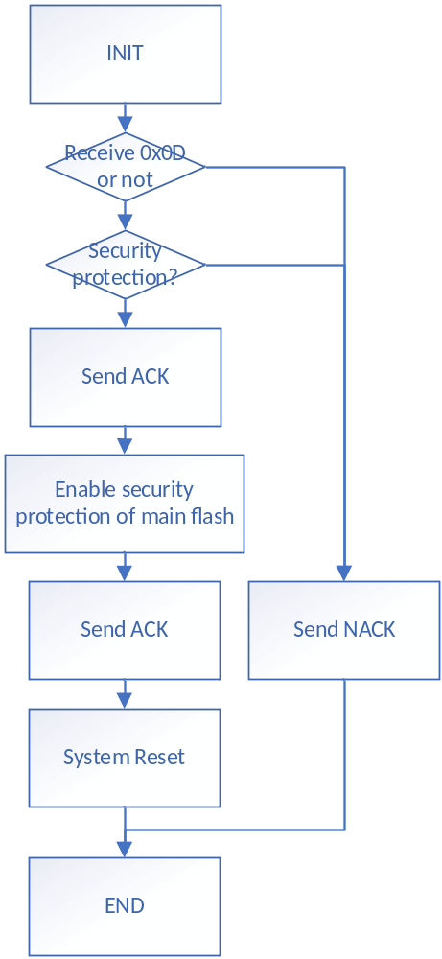

Disable Security Protection Command

UART

PC Flow
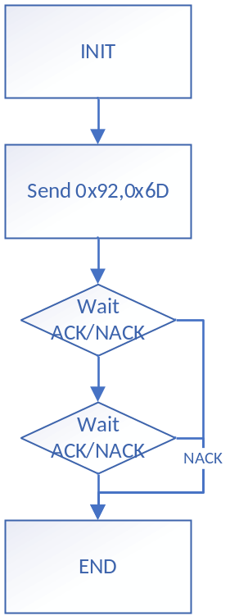

Boot Flow
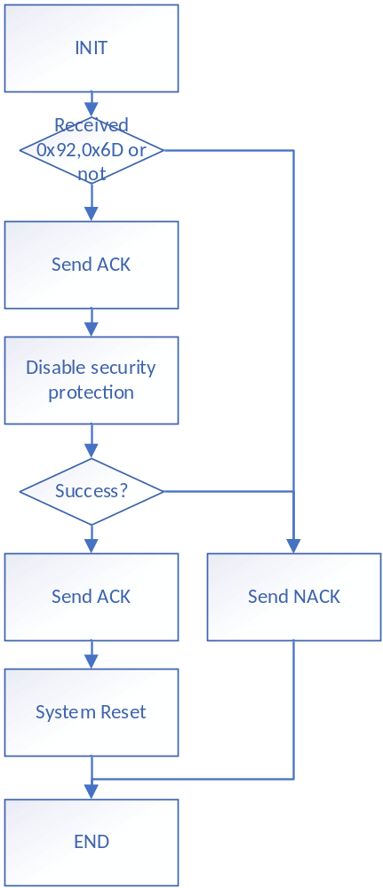

LIN

PC Flow
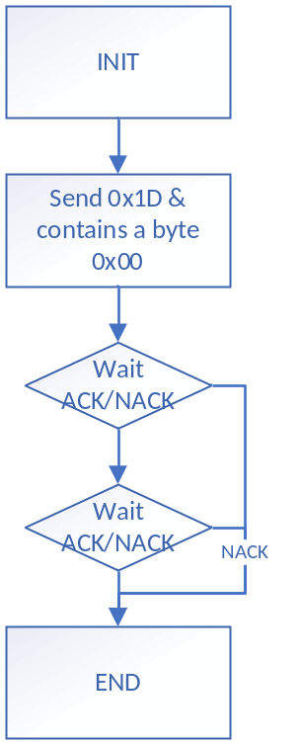

Boot Flow
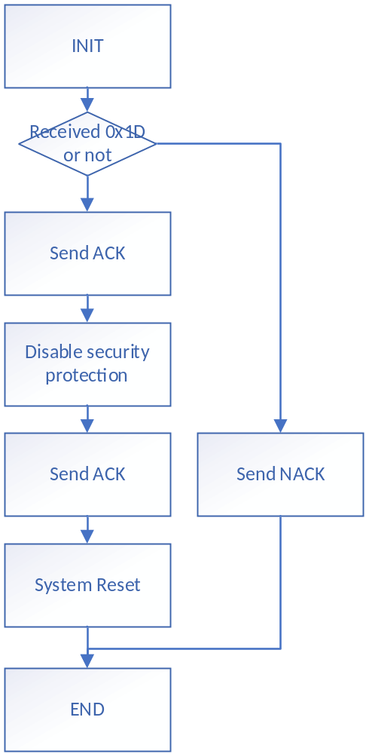

Update Key Command[New]

UART

PC Flow
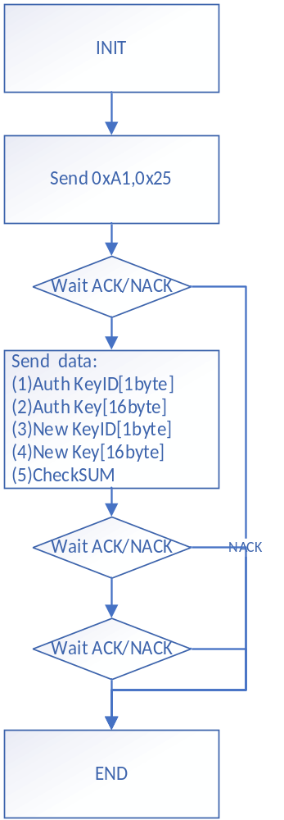

Boot Flow
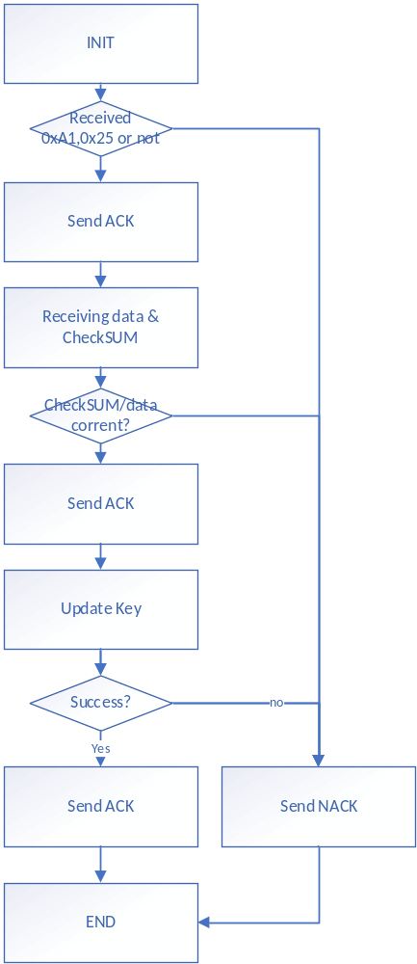

LIN
Same as UART

Delete All Key Command[New]

UART

PC Flow
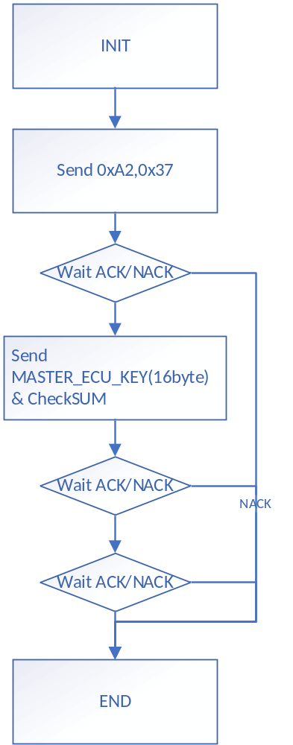

Boot Flow
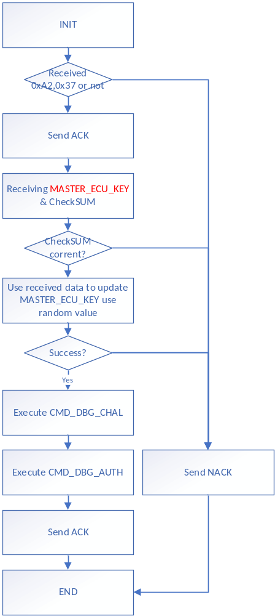

LIN
Same as UART

Get Firmware Information Command[New]

UART

PC Flow
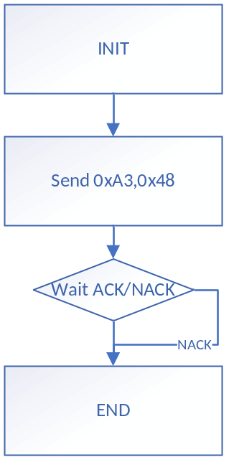

Boot Flow
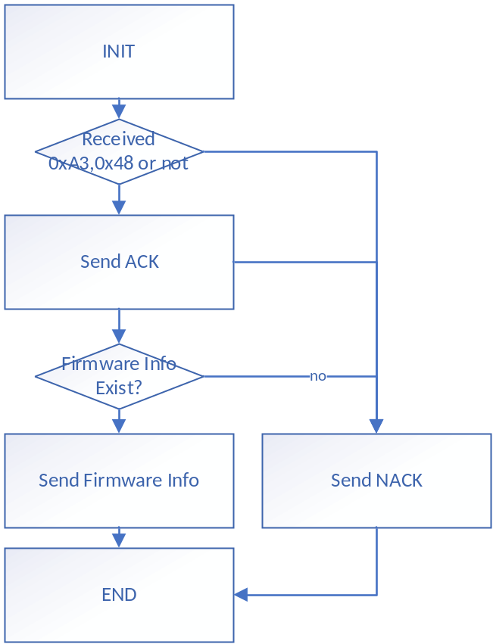

Execute Firmware Code
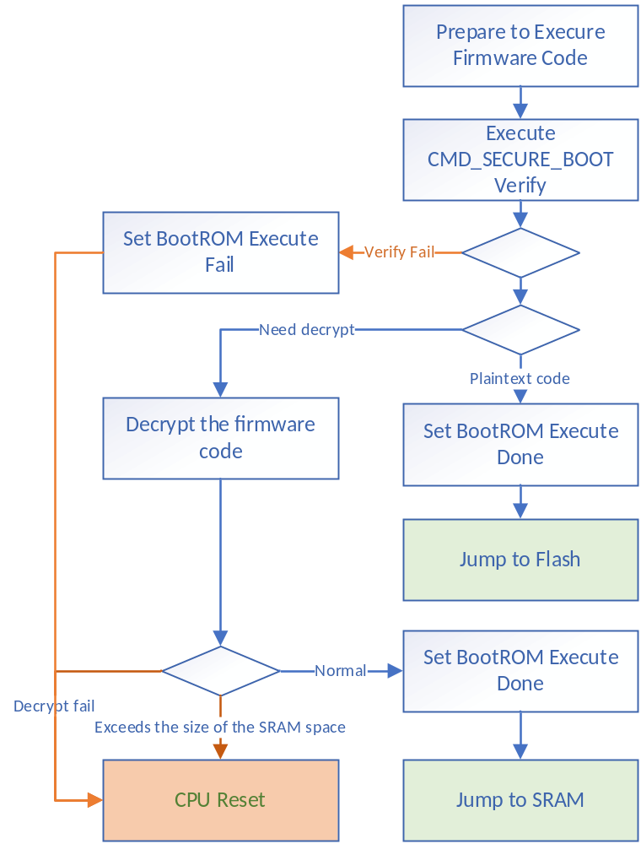

Update KEY

Update KEY
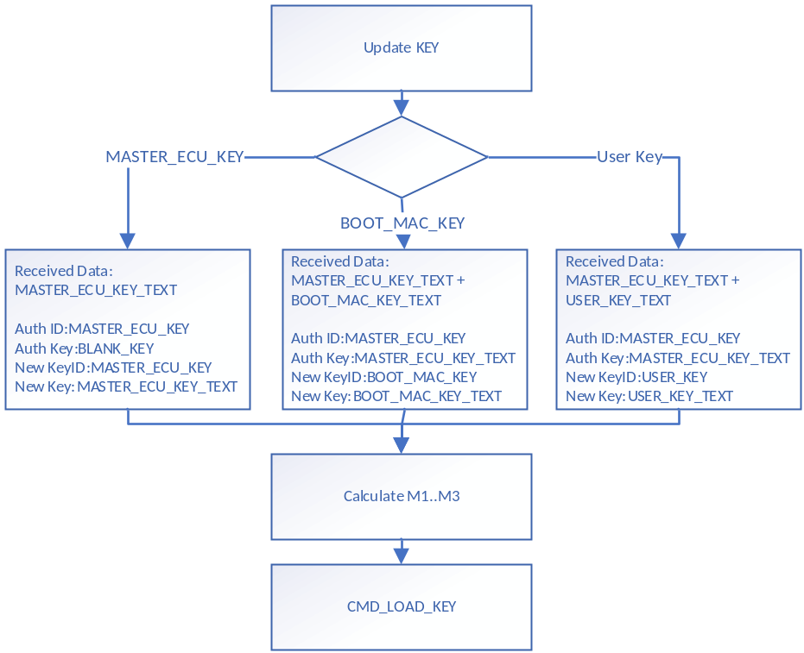

Update BOOT_MAC
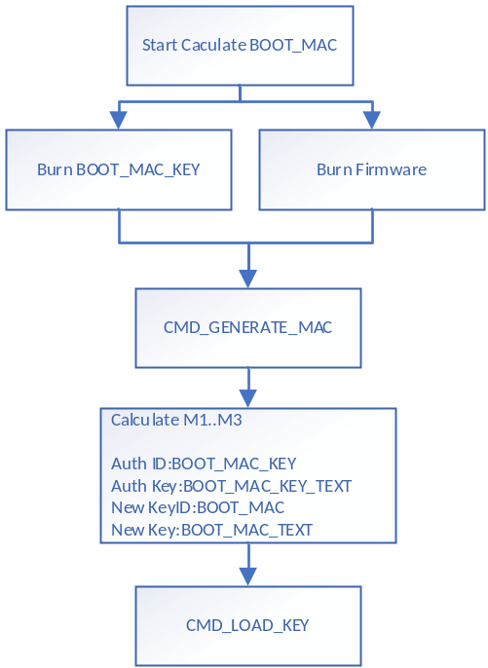

Flash Write

Normal Write
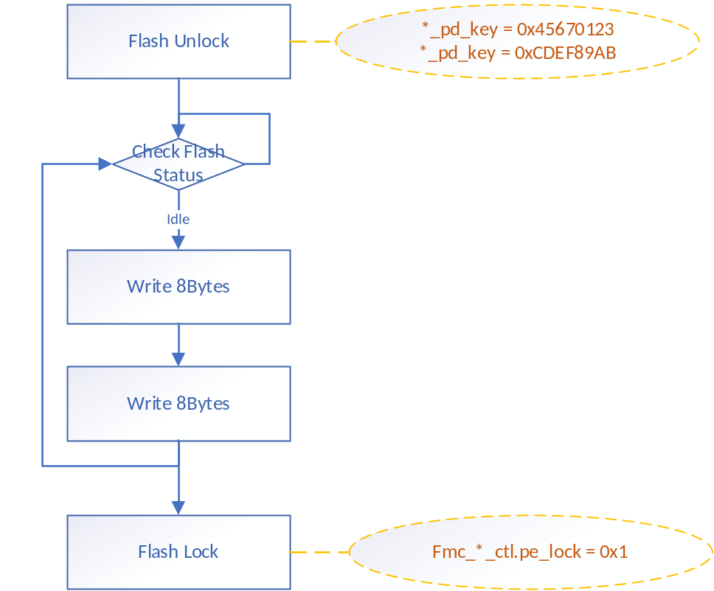

Fast Write
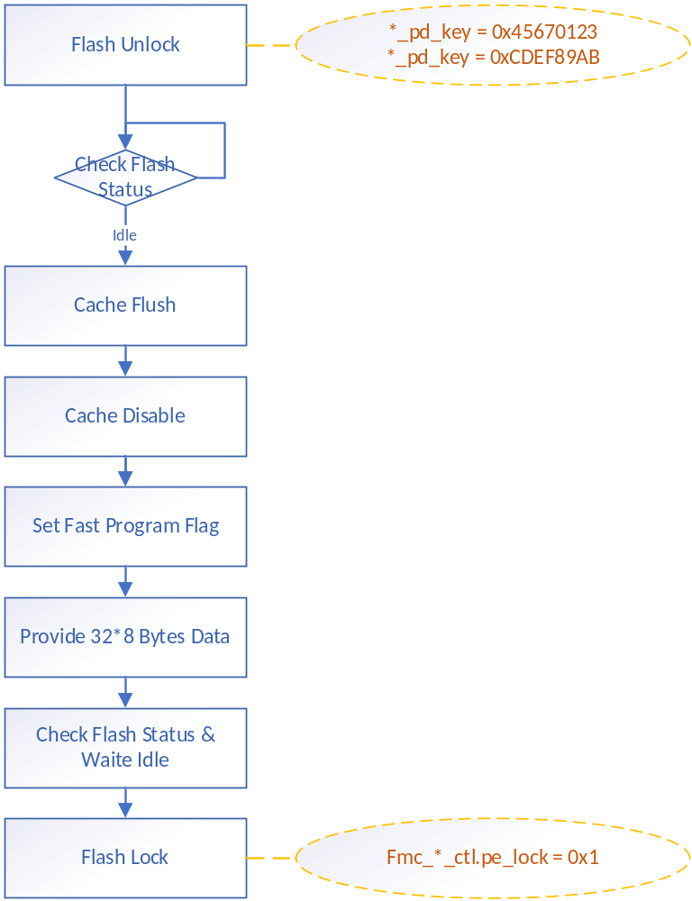

Option Byte Write
